**Business License Holders in the Town of Paradise**

**DEFENSIBLE SPACE AND LOT CLEARING**

***Property owners are responsible for keeping their lots fire safe year round, whether they live in Town or not***.

Rylee’s Goats 530.965.2534

Sierra Landscape & Maintenance 530.895.0263

T & L Construction 530.514.5162

Tristan’s Odd Jobs 530.321.7575

WhackyWeedWhackers of Paradise 530.762.8136

**Tree Services**

About Trees 530.343.4533

All Things Trees 530.872.7272

Arborcat Tree Service 707.396.0815

Bill Smith Forestry 530.774.0073

Crossfire Tree & Vegetation 530.877.9002

Paradise Stump Grinding 530.413.5600

The Davey Tree Expert Co. 866.661.4148

Tom’s Tree Service 530.877.6055

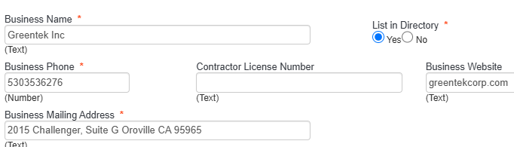

We do not endorse any of these companies, assembled from the Business License’s applied for at the TOP.

**Abatement/Lot Clearing/Defensible Space**

AT4 Wildland 530.327.4911

A Better Place 530.250.7414

A Helping Hand 323.839.8949

Abe’s Yard Clean 530.965.6490

Adams Garden 801.695.7339

Akin Brush Reduction 530.487.0415

B and R Landscaping 530.354.3830

Big D Hauling 530.720.2921

Bob Dylan Landscaping 530.713.9049

Brush Masters 530.720.9827

Crossfire Tree and Vegetation 530.877.9002

Dadco Construction 530.726.2981

D8 Enterprises, Inc. 530.301.5525

DB Earthwork & Lot Clearing 530.828.4542

Firestorm Wildland Fire Suppression 530.898.8153

Gelo’s Handyman and Landscaper 530.774.8750

Greentech, Inc. 530.353.6276

Greggs Yard Maintenance LLC 530.5153396

Joel Heaton Vegetation Mgmt. 530.370.5472

Lakes Home Service 530.966.5284

Let’s Landscape 530.650.3000

Lone Wolf Lawn Care & Landscape 530.519.2628

Paradise Weed Abatement 530.922.2525

Robinson’s Handyman Services 925.444.5410

Helping Hands LLC 323.839.8949