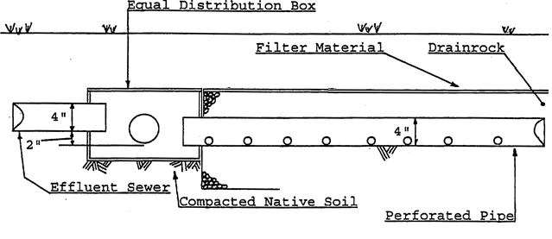

Effluent Sewer:

Equal Distribution Box:

Drain Rock:

Filter Material:

Four (4) inch minimum diameter, watertight, and of an approved material listed on the Approved Pipe Materials List. Pipe must have two (2) inches of fall per one hundred (100) feet of pipe run.

Must be of watertight and constructed from concrete, PVC plastic or fiberglass.

Cleaned, washed rock that contains no fine materials less than three quarters (3/4) of an inch in diameter and not greater than two and one half (2 1/2) inches in diameter.

Filter fabric or untreated building paper.

